PROJECT PROGRESS REPORT
PROJECT PROGRESS REPORT
(Reporting No. 10 / 10)
Reporting Period: From 17/08/2026 To24/09/2026
1. Student Information
Student Name | PATEL MAN VISHNUBHAI.
Enrollment Number | 25IC03CA053
Program/Branch | MCA (CA)/ ICA
Semester | 3
Contact Number | 8849948963
Email ID | 25ic03ca053@ppsu.ac.in

2. Project Details
Type | Research Project
Department/Domain | MCA CA (DS/ML) /AI &ML
Mentor Name | Mr. Srikant Singh
Start Date | 08-06-2026
End Date | 03-10-2026

3. Project Title
- OpenCV - Based System for Crack Identification and Width Estimation

4. Progress During the Reporting Period
A. Previous Reporting Review
Planned Task | Status | Remarks
Complete Main Project Documentation | In Progress | Preparing complete project documentation, including methodology, system design, and results.
Research Paper Writing | In Progress | Working on the research paper based on project implementation and findings.
Review Research Papers and References | Completed | Reviewed relevant research papers and organized references.
Resolve Minor Project Bugs | In Progress | Identifying and fixing minor bugs to improve system stability.
Final System Testing | Completed | Tested all major modules and verified the complete workflow.
Finalize Screenshots and Result Analysis | In Progress | Organizing project screenshots and analysis results for documentation.
Final Presentation Preparation | Pending | Preparing the final presentation and project demonstration.

B. Work Completed During This Reporting Period
- Reviewed the complete project workflow and verified all major modules.
- Organized project results, screenshots, and generated output files.
- Reviewed research papers and organized relevant references for the research paper.
- Started preparing the main project documentation, including methodology, system design, and results.
- Identified and worked on resolving minor project bugs.
- Performed additional testing to check system stability and measurement consistency.
- Analysed crack detection, width estimation, and risk classification results.
- Continued preparing the research paper based on the project implementation and findings.

C. Evidence / Deliverables Produced
Sr. No. | Deliverable / Evidence | Description / Link / Attachment
1 | Completed Project Source Code | Final Python code with all integrated crack detection, measurement, and analysis modules.
2 | Screenshots and Model Output | Crack detection results, width measurements, risk classification, and annotated images.
3 | CSV and ZIP Reports | Generated CSV analysis reports and ZIP packages containing project outputs.
4 | Final Testing Results | Testing and validation evidence for all completed project modules.
5 | Project Documentation | Documentation covering project methodology, system design, implementation, and results.
6 | Research Paper Review | Reviewed research papers, literature findings, and organized references.
7 | Research Paper Draft | Draft containing the research objectives, methodology, implementation, and project findings.
8 | Final Presentation Materials | Organized project screenshots, results, and materials for the final presentation and demonstration.
9 | Project Repository | GitHub: https://github.com/ManPatel448/OpenCV-Based-System-for-Crack-Identification-and-Width-Estimation.git

Image Upload:
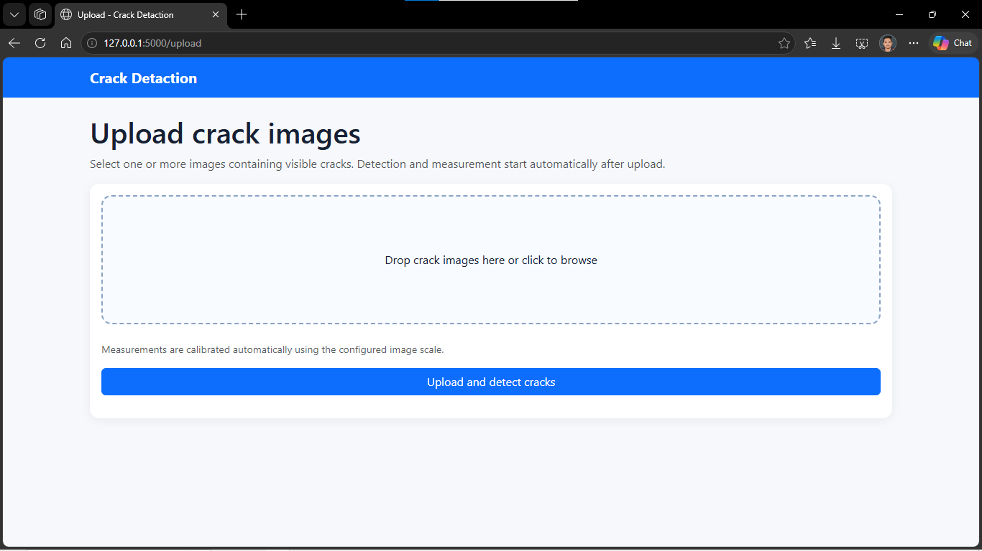
Proper Validation Only Crack Image to use:
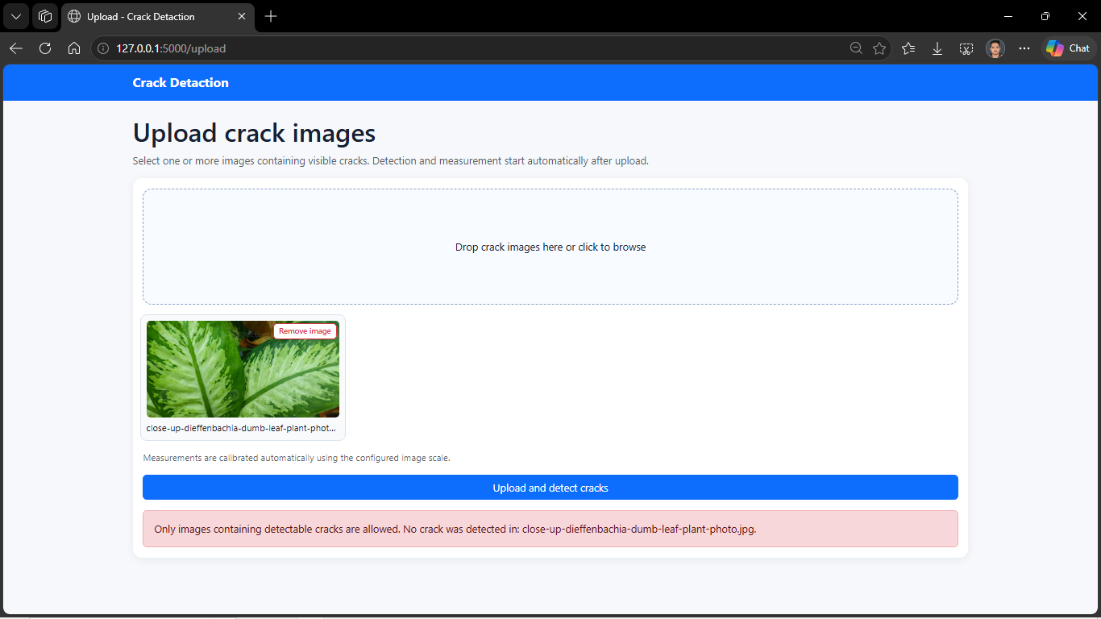
Crack Image:
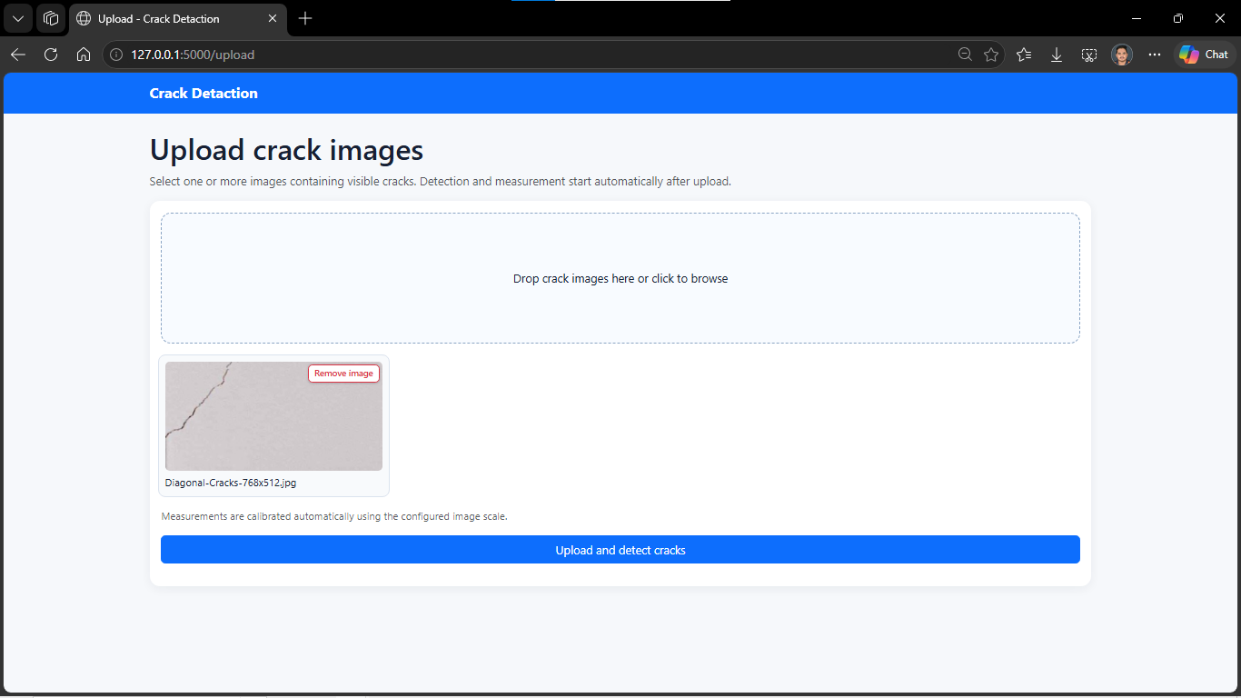
Output:
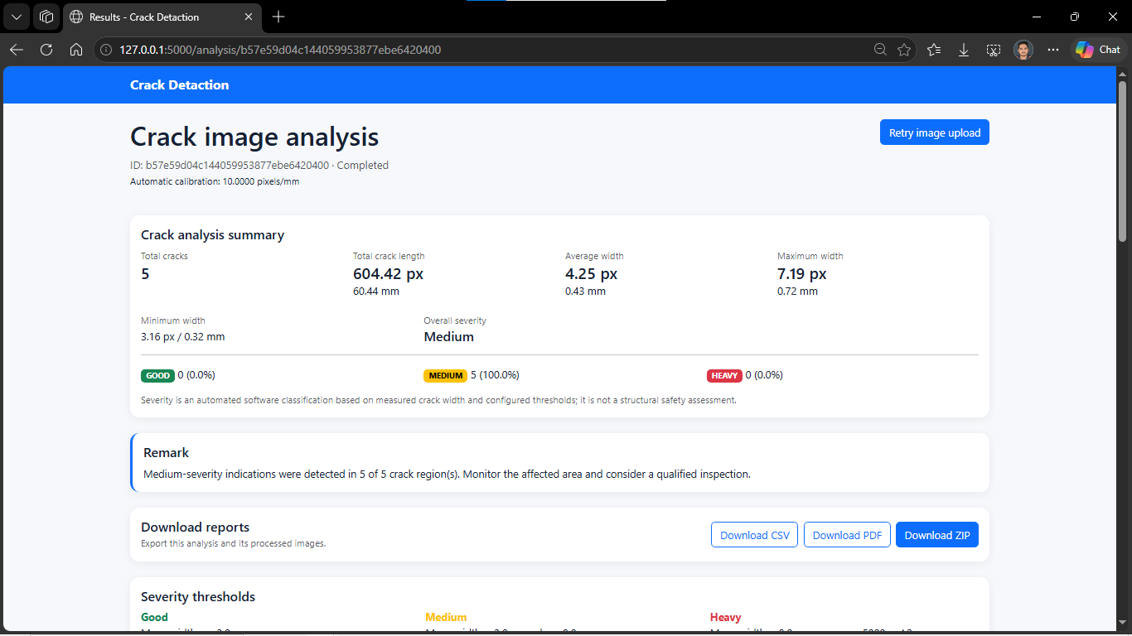
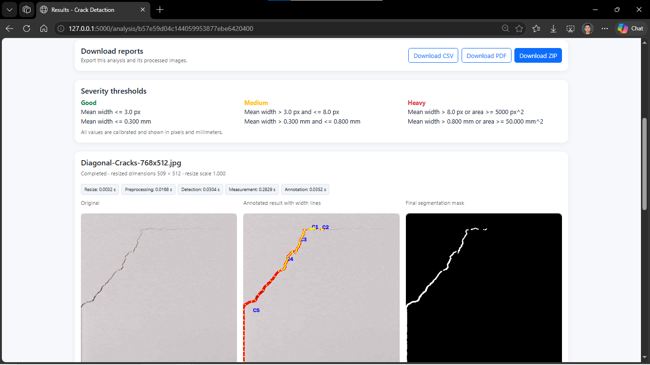
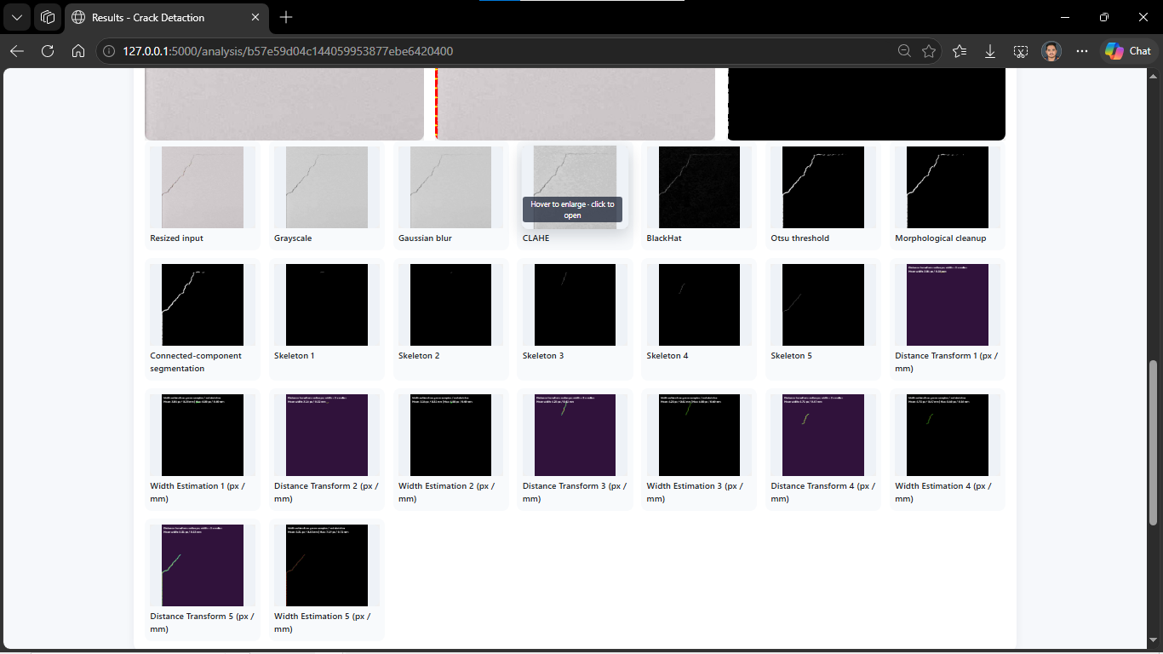
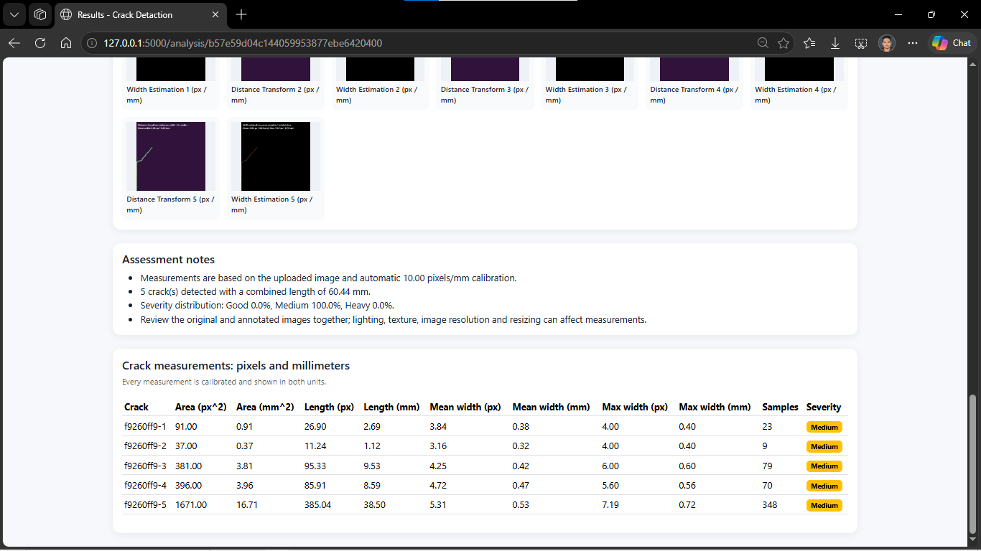

D. Current Project Progress
Overall Project Completion: 100%
Sr. No. | Project Component / Module | Status | Completion (%)
1 | Library Installation | Completed | 100%
2 | Import Libraries | Completed | 100%
3 | Project Configuration | Completed | 100%
4 | Image Upload | Completed | 100%
5 | Image Preprocessing | Completed | 100%
6 | Crack Segmentation | Completed | 100%
7 | Crack Detection | Completed | 100%
8 | Crack Width Estimation | Completed | 100%
9 | Risk Classification | Completed | 100%
10 | Result Visualization | Completed | 100%
11 | CSV Report | Completed | 100%
12 | ZIP Download | Completed | 100%
13 | Main Project Documentation | In Progress | 70%
14 | Research Paper Writing | In Progress | 50%
15 | Minor Bug Fixes and Final Review | In Progress | 80%

E. Challenges / Issues Faced
- Faced minor bugs during final project testing and system maintenance.
- Encountered challenges in organizing project results and screenshots for documentation.
- Faced difficulties in structuring the research paper and presenting technical findings clearly.
- Required additional verification of crack-width measurements and risk classification results.
- Needed to organize research references and maintain proper citation formats.
- Faced challenges in ensuring consistency between project outputs, analysis, and documentation.

F. Actions Taken / Solution Implemented
- Identified and resolved minor bugs to improve system stability.
- Organized project screenshots, output files, and analysis results for documentation.
- Reviewed crack detection and width estimation results for accuracy and consistency.
- Structured the main project documentation with methodology, system design, and results.
- Organized research papers, references, and citations for the research paper.
- Improved the presentation of technical findings and project outputs.
- Performed additional testing and verification of the completed system modules.

G. Plan for Next Reporting
- Complete the main project documentation with final results and analysis.
- Finalize the research paper writing and review its content.
- Resolve remaining minor bugs and perform final system verification.
- Organize final project screenshots, diagrams, and output evidence.
- Verify all references, citations, and research findings.
- Prepare the final project presentation and demonstration.
- Complete the final review and prepare all project files for submission.
H. Learning / Skills Acquired
- Improved Python and OpenCV skills through final testing and project maintenance.
- Gained practical experience in crack detection, width estimation, and result analysis.
- Enhanced debugging, troubleshooting, and problem-solving skills.
- Improved technical documentation and research paper writing skills.
- Learned research analysis, reference management, and citation formatting.
- Strengthened testing, validation, and quality assurance skills.
- Improved technical communication and project presentation skills.

5. Tasks Accomplished
- Completed final testing and verification of all major project modules.
- Organized project screenshots, output files, and crack analysis results.
- Reviewed research papers and finalized relevant references.
- Prepared the main project documentation structure and technical content.
- Analyzed crack detection, width estimation, and risk classification results.
- Identified and resolved minor project bugs.
- Improved system stability and verified measurement consistency.
- Continued research paper writing based on project implementation and findings.

6. Tasks in Progress / Next Plan
- Complete the main project documentation with final results and analysis.
- Finalize the research paper with proper references and citations.
- Resolve any remaining minor project bugs and perform final verification.
- Organize final screenshots, diagrams, and project output evidence.
- Review and refine the research findings and technical content.
- Prepare the final project presentation and demonstration.
- Complete the final review and prepare all project files for submission.

7. Learnings / Skills Acquired
- Improved Python programming and OpenCV skills through project development and testing.
- Gained practical knowledge of crack detection, segmentation, and width measurement.
- Enhanced debugging, troubleshooting, and system maintenance skills.
- Developed technical documentation and research paper writing skills.
- Improved research analysis, reference management, and citation formatting.
- Strengthened testing, validation, and result analysis skills.
- Improved technical communication, presentation, and project management skills.
References:
- Li, Y. (2026). Crack Detection and Semantic Segmentation in Concrete Structures Using an Improved Deep Learning-Based Framework. Journal of Engineering and Applied Science, 73, 107.

- Grzesiak, S., Nogatz, T., de Sousa, C., Kronenberger, M., Redenbach, C., & Pahn, M. (2026). In Situ 4D Image Analysis of Crack Width and Strain Changes in GFRP-Reinforced Concrete. Materials and Structures, 59, 197.

- Hassouna, M., Marzouk, M., & Fathalla, E. (2026). Automated Low-Cost Framework for Crack Measurements in RC Structures Using Deep Learning Approach. Scientific Reports, 16, 14678.

- Peng, S., Zhao, B., Cao, J., et al. (2026). A Review of Machine Learning-Based Methods for Concrete Crack Detection. Journal of Intelligent Construction, 4(2), 9180121.
Evaluation (To be filled by Mentor)
Criteria | Bloom's Level | Excellent (20) | Good (15) | Average (10) | Poor (5) | Marks
Progress as per Previous Plan | L3–Apply | All planned tasks completed | Most completed | Partial completion | Very little progress
Technical / Research Implementation | L4–Analyze | Excellent implementation with clear evidence | Good implementation | Basic implementation | Insufficient evidence
Quality of Deliverables | L5–Evaluate | High-quality, validated deliverables | Good quality | Acceptable | Poor / incomplete
Problem Solving & Challenges | L4–Analyze | Challenges clearly identified and effectively solved | Most issues addressed | Limited solutions | No clear effort
Planning for Next Phase | L6–Create | Clear, realistic and measurable plan | Mostly clear plan | Basic plan | No proper plan
Documentation & Presentation | L3–Apply | Well-structured and professional | Minor issues | Average clarity | Poor documentation
Total marks out of 100

Evaluation
Student Signature | Mentor (Institute)  Signature

Mentor (Institute) Remarks
________________________________________________________________________________________________________________________________________________________________________________________________________________________________________________________________________________________________________________________________________________________________________________________________________________________________________________________________________________________________________________________________________________________________________________________________________________________________________________________________________________________________________________________________________________________________________________________________________________________________________________________________________________________________________________________________________________________________________________________________________________________________________________________________________________________________________________________________________________________________________________________________________________________________________________________________________________________________________________________________________________________________________

